**MEDICAL INVENTORY OPTIMIZATION**

**(By Sadnya kolhe)**

DATA VISUALIZATION (USING PYTHON LIBRARY MATPLOTLIB)

**#Import file and libraries**

**Code:-**

from google.colab import drive

drive.mount('/content/drive')

import pandas as pd

import numpy as np

import matplotlib.pyplot as plt

pip install sns

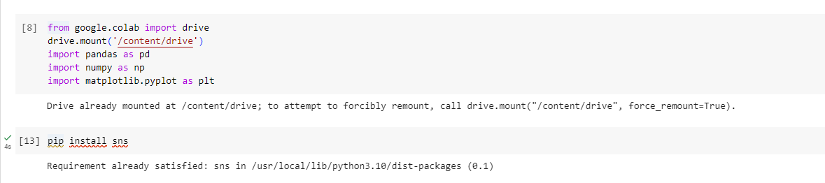

**# To read Data:**

**Code:-**

import pandas as pd

d=pd.read_csv('/content/drive/MyDrive/python colab/csvfile.csv')

df=pd.DataFrame(d)

print(d)

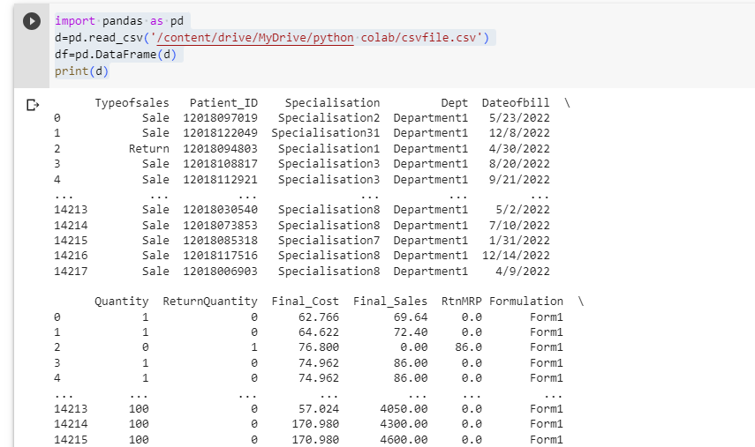

**# To plot hist plot of “Quantity”**

**Code:-**

sns.set_theme(style='darkgrid')

sns.histplot(d.Quantity)

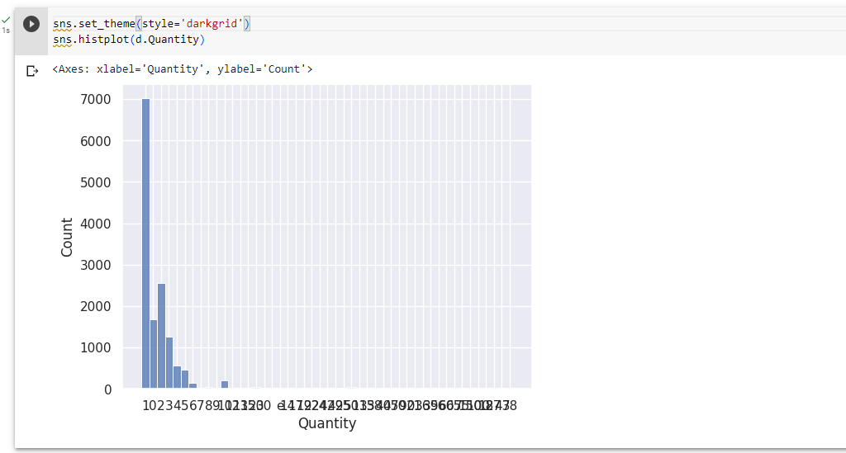

**# To plot hist plot of “ReturnQuantity”**

**Code:-**

sns.set_theme(style='darkgrid')

sns.histplot(d.ReturnQuantity)

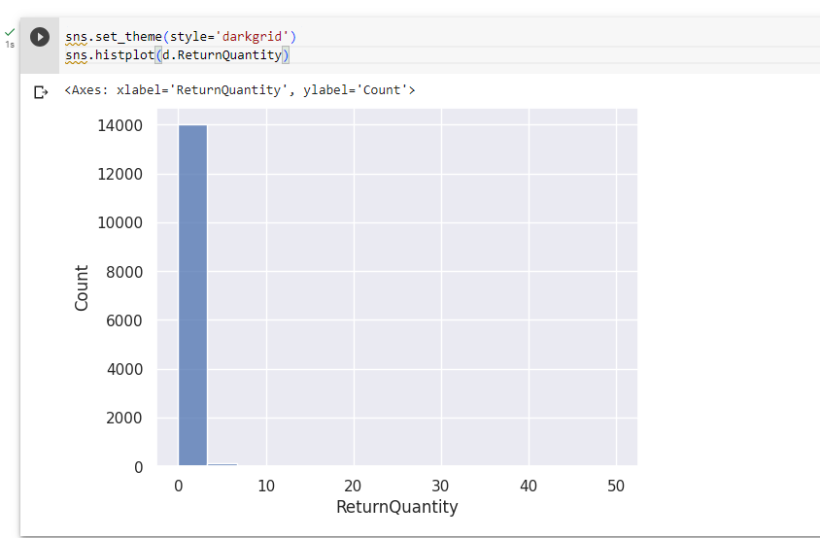

**#The scatterplot of Quantity and ReturnQuantity**

**Code:-**

sns.scatterplot(x="Quantity", y="ReturnQuantity", data=d)

plt.title("Quantity vs. ReturnQuantity")

plt.show()

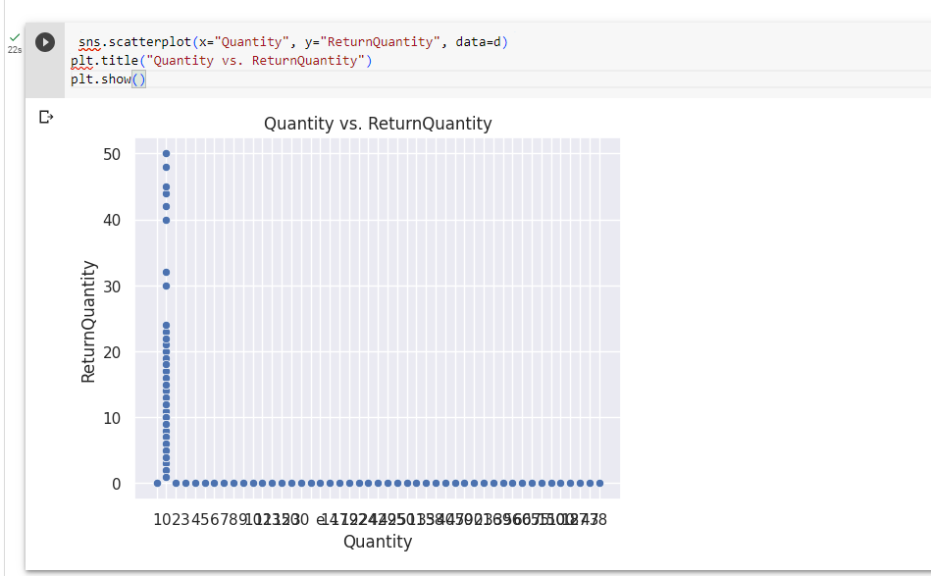

**#The scatterplot of Quantity and ReturnQuantity**

**Code:-**

sns.scatterplot(x="Final_Cost", y="Final_Sales", data=d)

plt.title("Final_Cost vs. Final_Sales")

plt.show()

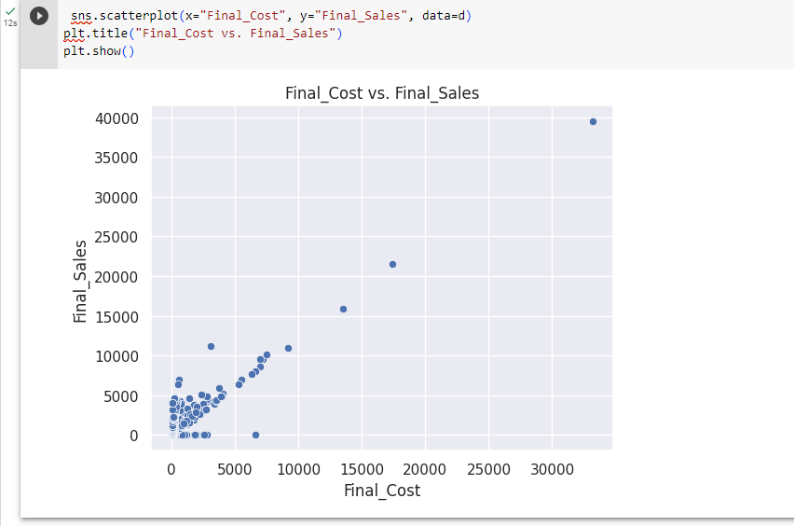

**#The Boxplot of Quantity and ReturnQuantity**

**Code:-**

sns.boxplot(x="Quantity", y="ReturnQuantity", data=d)

plt.title("Relation between Quantity and REturn quantity")

plt.show()

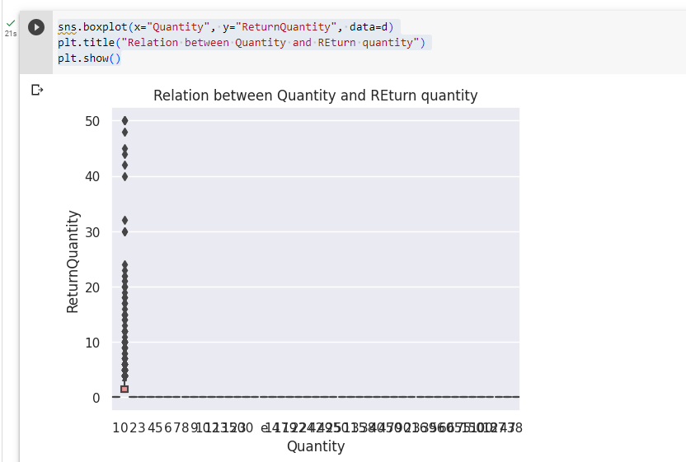

**#The Boxplot of Quantity and ReturnQuantity**

**Code:-**

sns.boxplot(x="Final_Sales", y="Final_Cost", data=d)

plt.title("Relation between Final_cost and Final_Sales")

plt.show()

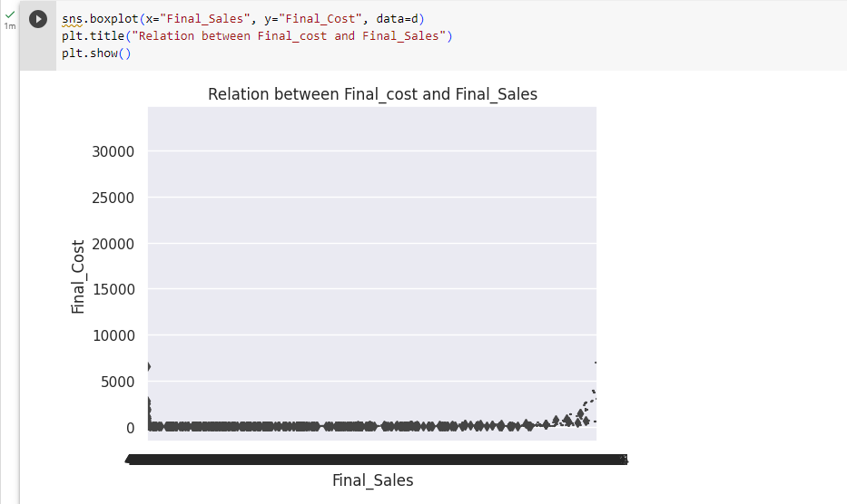

**#The pairplot between Final cost ,final sale and RtnMRP**

**Code:-**

sns.pairplot(d, vars=["Final_Cost", "Final_Sales", "RtnMRP"], hue="Quantity")

plt.title("Pairwise Relationships")

plt.show()

